# 03. Break These Five Myths

1. Break these 5 myths otherwise you cannot become effective communicator.
2. 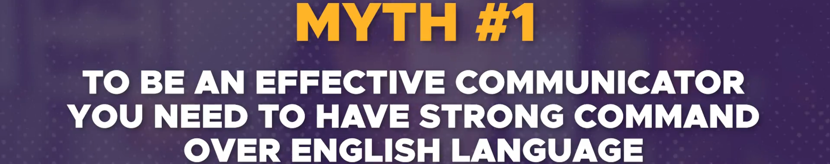  
     
     
   
3. 



1.   
     
   There are other ways of communication like the visual communications:  
   
2. **Source of confidence**:  
   
3. 
4.   
     
   We consider that sending email from our side is done and so communication is done.   
   On stage, speech is done, communication is done.   
   But this is just beginning. Communication is done when the meaning that we want to convey is understood by the receiver.

# Spoken Communication

## 3 Things You Need

1. 
2. 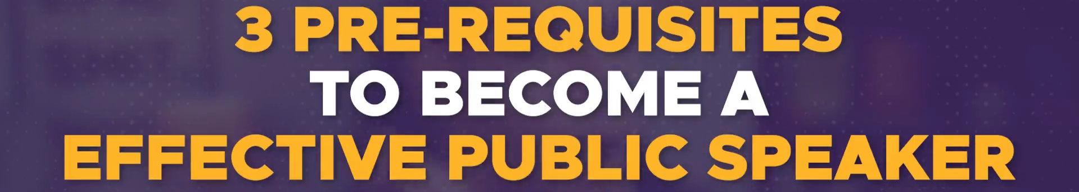
3. 
4. 
5. 
6. 
7. 
8. 
9. 
10. 
11. 

## 3 Things to Build Upon

1. 
2. 
3. 
4. 
5. 
6. 
7. 
8. If you don’t know to write, then you are not able to channelize your thoughts.
9.  
10. 
11. 
12. 
13. 
14. 
15. 
16. 
17. Brief about 3 things:  
      
      
    